AI & NLP APIs

🤖 What Are AI & NLP APIs?
# Source: Chatgpt (GPT-5-Mini) at [1/19/2026]
AI & NLP APIs (Artificial Intelligence & Natural Language Processing APIs) are web service interfaces that allow developers to use machine learning, language understanding, and AI models without building them from scratch.
They provide tools for understanding, generating, translating, analyzing, or classifying text, images, speech, and more — making apps smarter and more interactive.

🧠 Key Features of AI & NLP APIs
# Source: Chatgpt (GPT-5-Mini) at [1/19/2026]
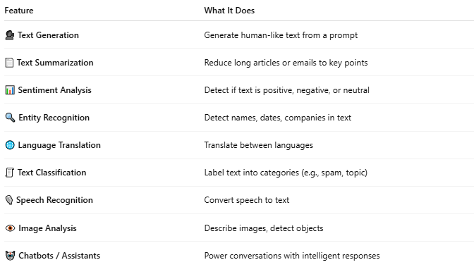

Feature | What It Does
🗣️ Text Generation | Generate human-like text from a prompt
📄 Text Summarization | Reduce long articles or emails to key points
📊 Sentiment Analysis | Detect if text is positive, negative, or neutral
🔍 Entity Recognition | Detect names, dates, companies in text
🌐 Language Translation | Translate between languages
🧾 Text Classification | Label text into categories (e.g., spam, topic)
🎙️ Speech Recognition | Convert speech to text
👁️ Image Analysis | Describe images, detect objects
🤖 Chatbots / Assistants | Power conversations with intelligent responses

🔍 Examples of AI & NLP APIs
# Source: Chatgpt (GPT-5-Mini) at [1/19/2026]
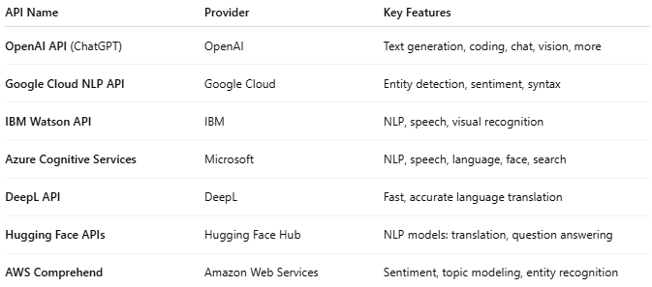

API Name | Provider | Key Features
OpenAI API (ChatGPT) | OpenAI | Text generation, coding, chat, vision, more
Google Cloud NLP API | Google Cloud | Entity detection, sentiment, syntax
IBM Watson API | IBM | NLP, speech, visual recognition
Azure Cognitive Services | Microsoft | NLP, speech, language, face, search
DeepL API | DeepL | Fast, accurate language translation
Hugging Face APIs | Hugging Face Hub | NLP models: translation, question answering
AWS Comprehend | Amazon Web Services | Sentiment, topic modeling, entity recognition

📤 Example: Sentiment Analysis (Google Cloud NLP)
# Source: Chatgpt (GPT-5-Mini) at [1/19/2026]
Request:
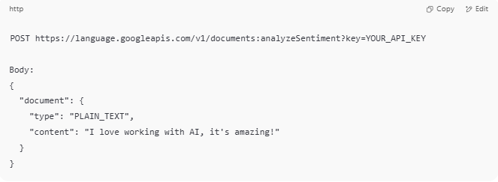
POST https://language.googleapis.com/v1/documents:analyzeSentiment?key=YOUR_API_KEY

Body:
{
"document": {
"type": "PLAIN_TEXT",
"content": "I love working with AI, it's amazing!"
}
}

Response:
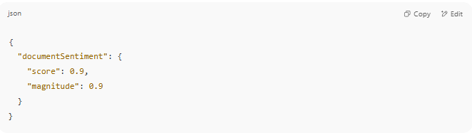
{
"documentSentiment": {
"score": 0.9,
"magnitude": 0.9
}
}

🗣️ Example: ChatGPT via OpenAI API
# Source: Chatgpt (GPT-5-Mini) at [1/19/2026]
Request (text completion):
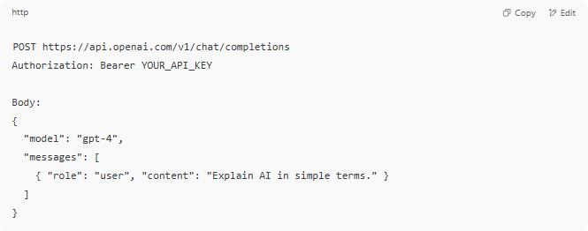
POST https://api.openai.com/v1/chat/completions
Authorization: Bearer YOUR_API_KEY

Body:
{
"model": "gpt-4",
"messages": [
{ "role": "user", "content": "Explain AI in simple terms." }
]
}

Response:
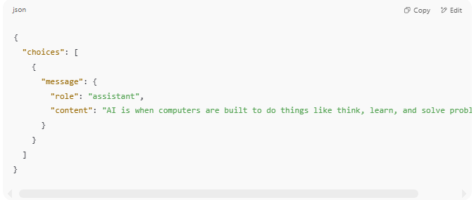
{
"choices": [
{
"message": {
"role": "assistant",
"content": "AI is when computers are built to do things like think, learn, and solve problems..."
}
}
]
}

💡 Use Cases
# Source: Chatgpt (GPT-5-Mini) at [1/19/2026]
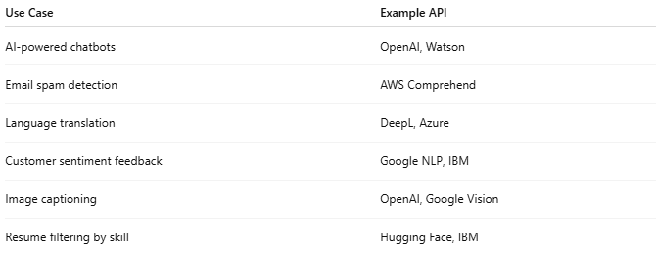

Use Case | Example API
AI-powered chatbots | OpenAI, Watson
Email spam detection | AWS Comprehend
Language translation | DeepL, Azure
Customer sentiment feedback | Google NLP, IBM
Image captioning | OpenAI, Google Vision
Resume filtering by skill | Hugging Face, IBM

🔐 Common Access Requirements
# Source: Chatgpt (GPT-5-Mini) at [1/19/2026]
- API keys
- Usage limits or quotas
- Paid plans for large usage or advanced models

